Project Design Phase-II Technology Stack (Architecture & Stack)

|  |  |
| --- | --- |
| Date | 19 October 2022 |
| Team ID | PNT2022TMID31081 |
| Project Name | Emerging Methods for Early Detection of  Forest Fires |
| Maximum Marks | 4 Marks |

Technical Architecture:

Title: Emerging Methods for Early Detection of Forest Fire

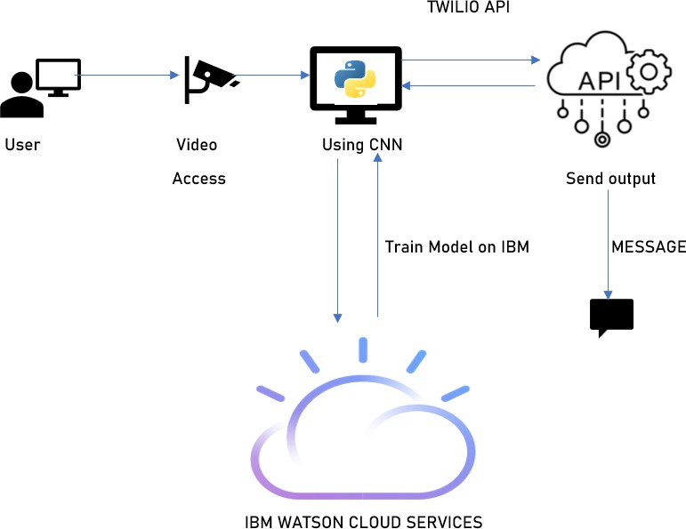

Table-1 : Components & Technologies:

|  |  |  |  |
| --- | --- | --- | --- |
| **S.No** | **Component** | **Description** | **Technology** |
| 1. | User Interface | How user interacts with application e.g. Web  UI, Mobile App, Chatbot etc. | HTML, CSS, JavaScript / Angular Js /  React Js etc. |
| 2. | Application Logic | Logic for a process in the application | Java / Python |
| 3. | Video Feed | Extract video by the camera | Surveillance Camera |
| 4. | Image Pre-Processing | To classify millions of feeds which have been extracted | Keras, Numpy |
| 5. | Database | Database Service on Cloud | IBM Cloud Watson |
| 6. | Training & Testing the Model | Training the model continuously to determine the fire | CNN |
| 7. | External API | To alert the user by messages | Twilio API, Open CV |

Table-2: Application Characteristics:

|  |  |  |  |
| --- | --- | --- | --- |
| **S.No** | **Characteristics** | **Description** | **Technology** |
| 1. | Open-Source Frameworks | Python open-source frameworks used | Technology of Opensource framework |
| 2. | Security Implementations | List all the security / access controls implemented,  use of firewalls etc. | SHA-256, Encryptions, IAM Controls |
| 3. | Scalable Architecture | Justify the scalability of architecture (3 – tier, Micro- services) | Web Services- HTML, CSS, JS Application Services- Python, Anaconda Database Services – IBM DB |
| 4. | Availability | Justify the availability of application | IBM Load Balancer |
| 5. | Performance | Design consideration for the performance of the application | IBM Content Delivery Network |